Julian Burgoff

12/16/2022

Analysis of Environmental Data

Lab 12

1. Chart, line chart

   Description automatically generated
2. 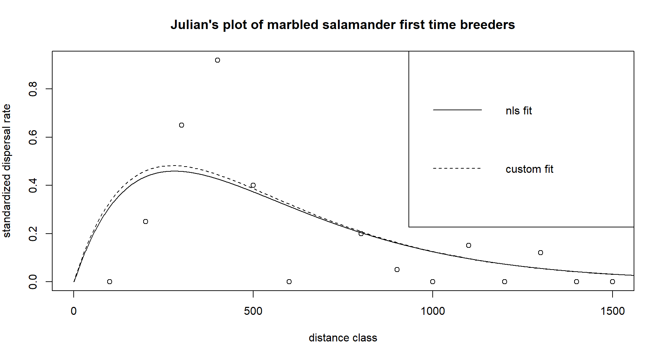
3. df AIC

fit_GCKI_ba_tot 2 1369.379

fit_GCKI_slope 2 1432.615

fit_GCKI_both_additive 3 1355.951

fit_GCKI_both_interactive 4 1353.007

1. I would choose the interactive model because it has the lowest AIC
2. There is an insignificant negative relationship between GCKI presence and slope. There is a significant positive relationship between GCKI presence and basal area. There is a (barely) significant negative relationship between GCKI and the interactive effects of slope and basal area.
3. 